I am looking for a countertop banana holder

ChatGPT said:
Here are some well-rated countertop banana holders you might like — from minimalist to decorative styles — that make a nice addition to a kitchen.

🍌 Recommended Countertop Banana Holders

Yamazaki Home Tosca Banana Stand
$26.00
•
Yamazaki Home + others

Bambloom Bamboo Banana Holder
$15.99
•
Walmart - Seller

Spectrum Diversified Euro Banana Holder
$22.09
•
Kohl's + others

Delavan Collection 2-Tier Fruit Basket with Banana Hanger
$34.00
•
Target + others

Black Bar Metal Banana Holder
$19.99
•
At Home + others
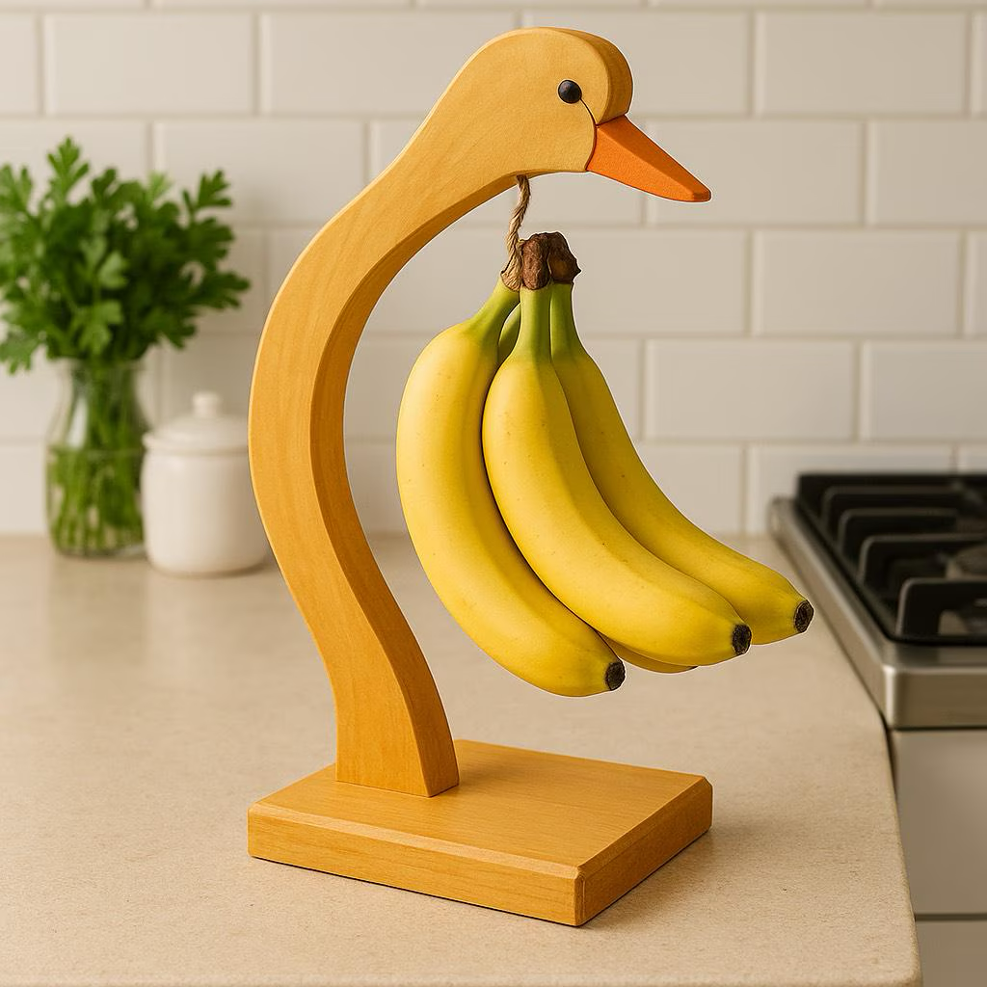
Handmade Wooden Duck Banana Holder
$35.00
•
Etsy

Rebrilliant Fruit Holder Banana Stand
$21.99
•
Wayfair

2-Tier Countertop Fruit Basket with Banana Hangers
$10.89
•
Walmart + others

Quick highlights
- Yamazaki Home Tosca Banana Stand — Clean, minimalist design that blends seamlessly with modern kitchens. Highly rated (4.6/5) for sturdiness and compact footprint, so it’s ideal if you want something functional yet stylish.
- Bambloom Bamboo Banana Holder — An affordable, natural-look bamboo stand that’s light, easy to clean, and does a solid job of keeping bananas elevated and fresh. Great for a small kitchen or budget-conscious setup.
- Spectrum Diversified Euro Banana Holder — A classic banana hanger stand that gets the job done without fuss — good balance of price, stability, and space-saving design.
- Delavan Collection 2-Tier Fruit Basket with Banana Hanger — Combines a banana hanger with a fruit basket — useful if you want to store bananas plus other fruit/produce in one footprint.
- Black Bar Metal Banana Holder — Sleek black metal option for a more industrial or modern kitchen vibe. Great if you care about aesthetics but still want a functional holder.
- Handmade Wooden Duck Banana Holder — A more decorative, whimsical pick — doubles as kitchen decor while holding bananas. Good choice if you like a unique touch in the kitchen.
- Rebrilliant Fruit Holder Banana Stand — A sturdy, well-reviewed stand that can support larger or heavier banana bunches. Nice balance of practicality and style.
- 2-Tier Countertop Fruit Basket with Banana Hangers — A budget-friendly, multipurpose option: holds bananas and other fruit/veggies. Useful if you want to cut down on clutter and maximize counter storage.

Why a Banana Holder Is Worth It
- Hanging bananas keeps them off the counter, reducing bruising and pressure that accelerates over-ripening. Nauradika+1
- Improves air circulation and can help bananas ripen more evenly — which can extend freshness. Natural House+1
- Helps free up countertop or fruit-bowl space and reduces clutter. Natural House+1

If you like — I can filter these picks to fit your kitchen style: modern / minimal, rustic / farmhouse, or small-space compact.
Do you want me to build that curated shortlist for you now (assuming your kitchen is more modern)?


Sources

You said:
Needs to be strong. White counters and backsplash and cabinets. Black faucets. Modern

ChatGPT said:
Cool — since you want something strong, modern, minimal, and black to match your white counters, backsplash and black faucets, I picked a handful of countertop banana holders that should match your aesthetic and be sturdy enough for everyday use 👇

🍌 Recommended Strong + Modern Banana Holders for Your Kitchen

Black Bar Banana Holder
$19.99
•
At Home + others

Yamazaki Home Banana Hanger
$23.00
•
Yamazaki Home + others

Spectrum Diversified Ashley Banana Holder
$13.99
•
Stones Ace of + others
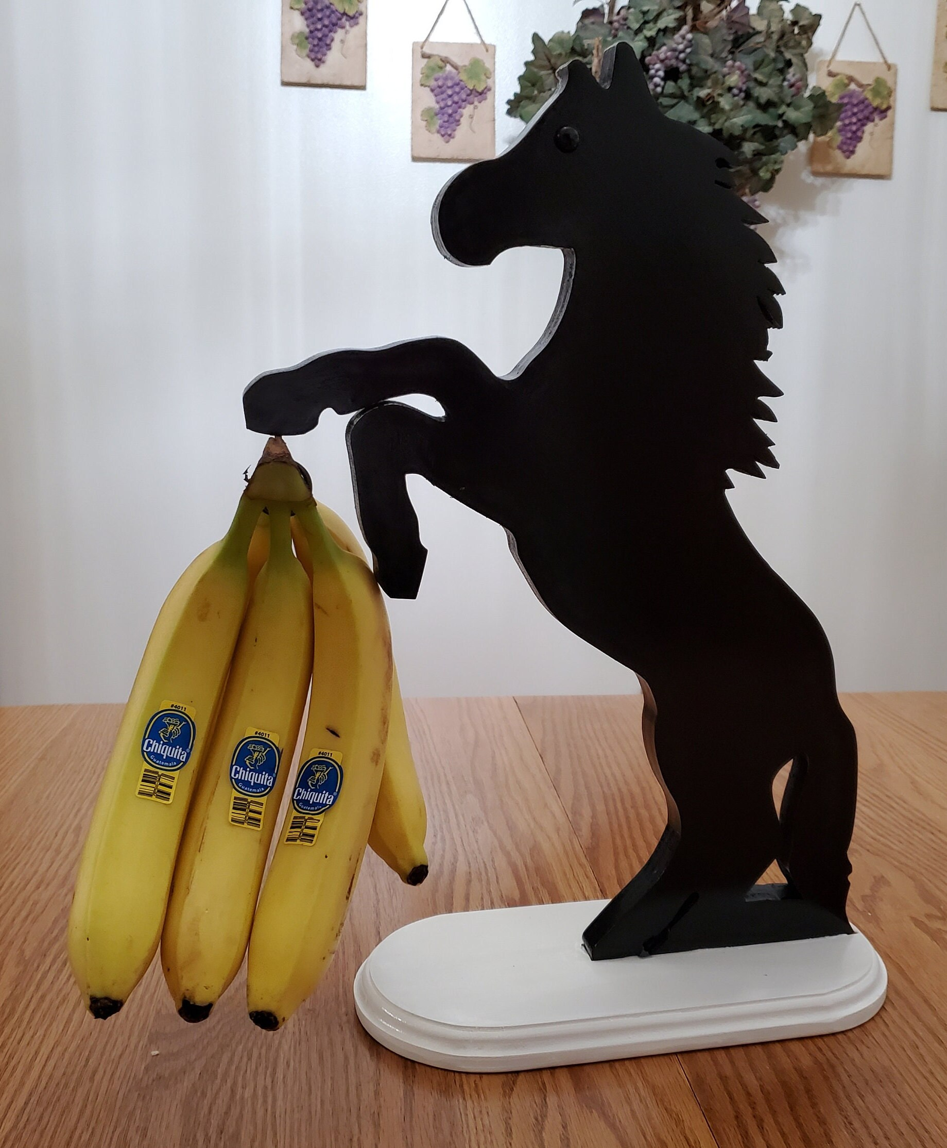
Black Stallion Banana Holder
$84.25
•
Etsy
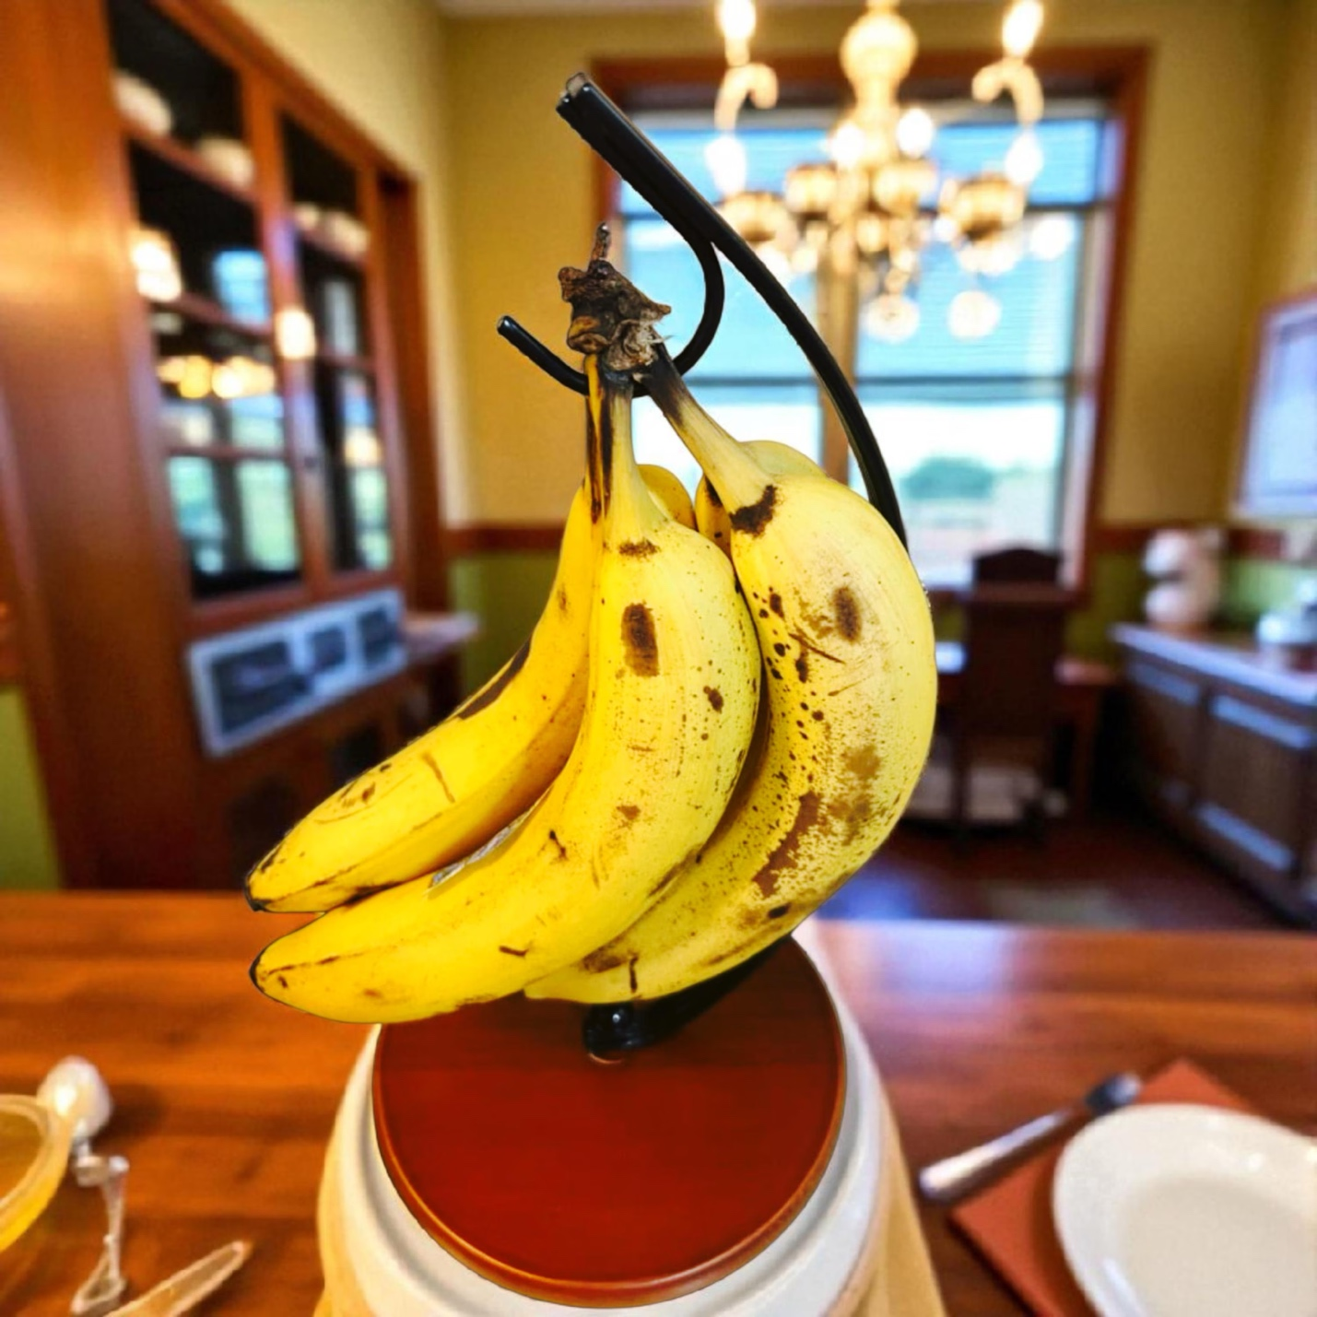
VEMBOLISH Modern Banana Holder Stand
$24.00
•
Etsy

Mercer41 Metal Banana Holder
$19.99
•
Wayfair
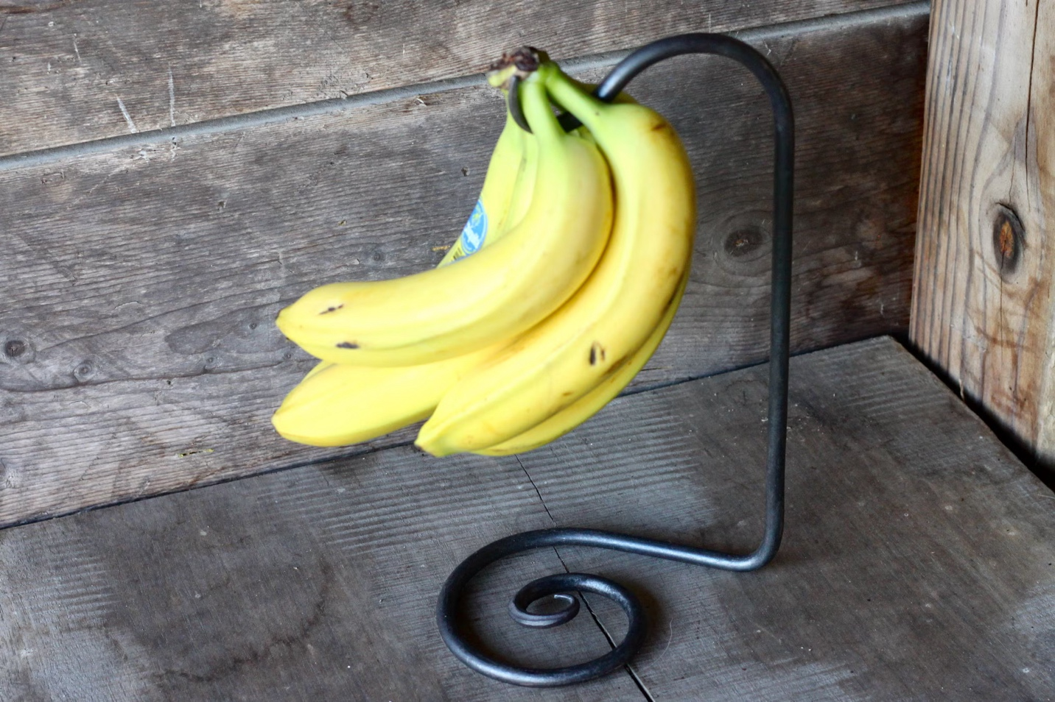
WicksForge Hand-Forged Metal Banana Stand
$51.00
•
Etsy

Threshold 2-Tier Fruit Basket with Banana Hanger
$34.00
•
Target + others

Quick take-aways
- Black Bar Banana Holder — Sleek all-black metal holder. Its minimalist look and stable base make it very well suited to a kitchen with white counters and black fixtures. Great balance of style + practicality.
- Yamazaki Home Banana Hanger — Known for minimalist, modern design; good for small-cabinet kitchens and matches modern black-metal fixtures very well. Hanging bananas helps prevent bruising and keeps countertop looking clean.
- Spectrum Diversified Ashley Banana Holder — A sturdy steel holder at a budget price. Reliable for everyday use if you want something simple and functional without fuss.
- Black Stallion Banana Holder — More heavy-duty, handmade option. If strength and durability are top priority (e.g. you often have heavy banana bunches or want something long-lasting), this is a robust choice.
- VEMBOLISH Modern Banana Holder Stand — Balanced, stable design with a minimalist black metal look — good if you want a clean modern aesthetic but still want to avoid tipping or instability.
- Mercer41 Metal Banana Holder — Solid midrange option with clean lines and a modern feel. A nice balance between style, price, and reliability.
- WicksForge Hand-Forged Metal Banana Stand — High-end, handmade metal stand. If you’re aiming for a premium, durable accent piece that fits a modern-industrial kitchen, this is one of the strongest options.
- Threshold 2-Tier Fruit Basket with Banana Hanger — If you like having fruit + bananas-in-one spot, this doubles as a fruit basket + banana stand — functional and attractive while keeping your counter more organized.

✅ My Recommendation for Your Setup
Since you described white counters & backsplash, black faucets, modern aesthetic, and wanting strong + stable — the top candidates for you are:
- Black Bar Banana Holder — sleek, simple, and consistent with black fixtures
- Yamazaki Home Banana Hanger — minimalist and modern look with good build quality
- WicksForge Hand-Forged Metal Banana Stand — if you want something durable and statement-quality
- VEMBOLISH Modern Banana Holder Stand — balanced design if you want style + stability

If you like — I can pull up 6–10 additional banana holders that match exactly your color scheme + strong-build requirement (including only black/white or black-metal) — might reveal some designer-grade or more premium picks.
Do you want me to build that extended list for you now?

You said:
Does the Yamasaki product fall over with heavy banana bunch?

ChatGPT said:
Good question. The Yamazaki Tosca Banana Stand can hold a typical banana bunch — but it does have some limitations, and yes: under certain conditions, it can tip or feel unstable. Here’s what I found (and what to watch out for if you get it).

⚠️ Stability Issues with Yamazaki’s Stand
- On the official product page, there’s a note from some owners that they “have to put rocks in the bottom to keep it from tipping over as bananas are too heavy — even just a few.” Yamazaki Home+1
- In reviews on major storefronts, some buyers say it feels “a little light-weight for the large bunches” they regularly have. Wayfair+1
- On the upside, other reviewers say it handles “10+ bananas” just fine and seems “solidly built.” Macy's+2Container Store+2
So the feedback is mixed — for small/medium banana bunches it’ll probably be fine, but with heavy or oversized bunches, tipping becomes a real possibility.

✅ What the Stand Does Well
- Good for a “normal” household banana bunch — it holds up to ~8 bananas comfortably according to the manufacturer. Amazon+1
- Minimalist, clean design works well with modern kitchens (especially white counters + black fixtures).
- Light and compact — easy to move or tuck away if needed.

💡 What I’d Do If I Were You (Given Your Setup: White counters + black faucets + modern look)
If you like the Yamazaki aesthetic but care about stability under heavier loads, you might:
- Use the stand only for small–medium banana bunches (e.g. 3–6 bananas).
- Put it on a non-slippery matte placemat or rubber pad to add grip.
- If you often buy heavy bunches or want future-proofing — consider a heavier, more stable banana stand (metal base or wider base) rather than Yamazaki.

If you want — I can pull up 5–10 banana holders that are much more stable than Yamazaki — all matching black/modern aesthetic + strong base (so you don’t have to worry about tipping).
Want me to build that alternate shortlist for you now?



Sources

You said:
Yes

ChatGPT said:
Cool — here’s a set of banana holders that are strong, stable, and work well with a modern black-and-white kitchen (so they match your counters, backsplash, black faucets, etc.). I picked ones with heavier bases or steel/metal build that are less likely to tip even under a big banana bunch.

🍌 Heavy-Duty / Stable Banana Holders — Modern + Black-Friendly

Black Bar Banana Holder
$19.99
•
At Home + others

PAMINGONO Black Metal Banana Hanger Stand
$18.90
•
Walmart - Seller

Rebrilliant Geistlinger Banana Holder
$21.99
•
Wayfair
WicksForge Hand-Forged Metal Banana Stand
$51.00
•
Etsy

Spectrum Diversified Ashley Banana Holder
$13.99
•
Stones Ace of + others

Basicwise Wire Metal Fruit Basket with Banana Hanger
$31.89
•
Home Depot + others

Ebern Designs Stergis Euro Banana Holder
$21.67
•
Wayfair

Smart Design Banana and Fruit Basket Holder Stand
$33.99
•
Walmart - Smart Design + others

💡 Why these stand out
- Black Bar Banana Holder — Sleek black-metal build, minimalist design, and solid reviews for stability. Great “match-your-kitchen” pick with white counters + black fixtures.
- PAMINGONO Black Metal Banana Hanger Stand — A simple metal hanger design with good structure; a good low-price, durable option if you want “set-and-forget” reliability.
- Rebrilliant Geistlinger Banana Holder — Combines a sturdy hook for banana bunches with a basket base for extra stability and bonus fruit storage. Great if you want counter organization beyond bananas.
- WicksForge Hand-Forged Metal Banana Stand — A premium, heavy, forged-metal stand. Its solidity and weight make it among the least likely to tip; good long-term investment if you want “buy once, forget it.”
- Spectrum Diversified Ashley Banana Holder — A budget-friendly steel stand: good for everyday use, and small enough to not dominate the counter. Not the heaviest, but reliable if you hang modest banana bunches.
- Basicwise Wire Metal Fruit Basket with Banana Hanger — Combines a basket for mixed fruit + banana hanger, adding weight and base-area for stability, which reduces tipping risk.
- Ebern Designs Stergis Euro Banana Holder — Stylish and sturdy steel build with enough height and balance to support larger bunches while blending with modern décor.
- Smart Design Banana and Fruit Basket Holder Stand — A heavier-duty metal holder with capacity for larger fruit loads; good choice if you often have big banana bunches or want to also store other fruit/veg.

✅ My Recommendation for You (Given Your Kitchen Style & Needs)
Since your kitchen is white counters + backsplash, black faucets, modern and likely minimalist, the top choices are:
- Black Bar Banana Holder — for clean lines and modern minimalism.
- WicksForge Hand-Forged Metal Banana Stand — if you want maximum stability and a “set-and-forget” premium piece.
- Rebrilliant Geistlinger Banana Holder — if you want some extra fruit or produce storage while keeping the aesthetic.
If you care most about weight, sturdiness, and no tipping ever — go for the forged-metal or heavy-base ones (like WicksForge or Rebrilliant). If you prefer simplicity + floor-space economy, Black Bar or PAMINGONO are solid.

If you like — I can pull up 4–5 banana holders that are designed for heavy bunches (10–15 lb load) — aimed at people that buy in bulk or keep bananas hanging for a long time. (Those are often overbuilt compared to standard stands.)

You said:
Are there models with a stone base?

ChatGPT said:
Yes — there are banana-holder models that use a stone (or marble) base for extra stability, which is ideal if you want something that won’t tip easily and matches a modern kitchen. Here are some good ones along those lines:

🥥 Banana Holders With Stone / Marble or Heavy Bases

Everous Modern Banana Holder Tree Stand with Marble Base
$29.07
•
eBay - chango-4596

Banana Holder With Marble Base, Metal Banana Hanger
$38.81
•
eBay - icebergdigital

Livabber Banana Holder with Marble Base
$27.20
•
eBay - kamtau589

Winmien Double Hooks Banana Holder with Marble Base
$22.97
•
Sears - zabiva + others

Marble Banana Holder
$33.98
•
Walmart - qingmi999 + others
WicksForge Hand Forged Metal Banana Stand
$51.00
•
Etsy

Ebern Designs Stergis Banana Holder
$21.67
•
Wayfair
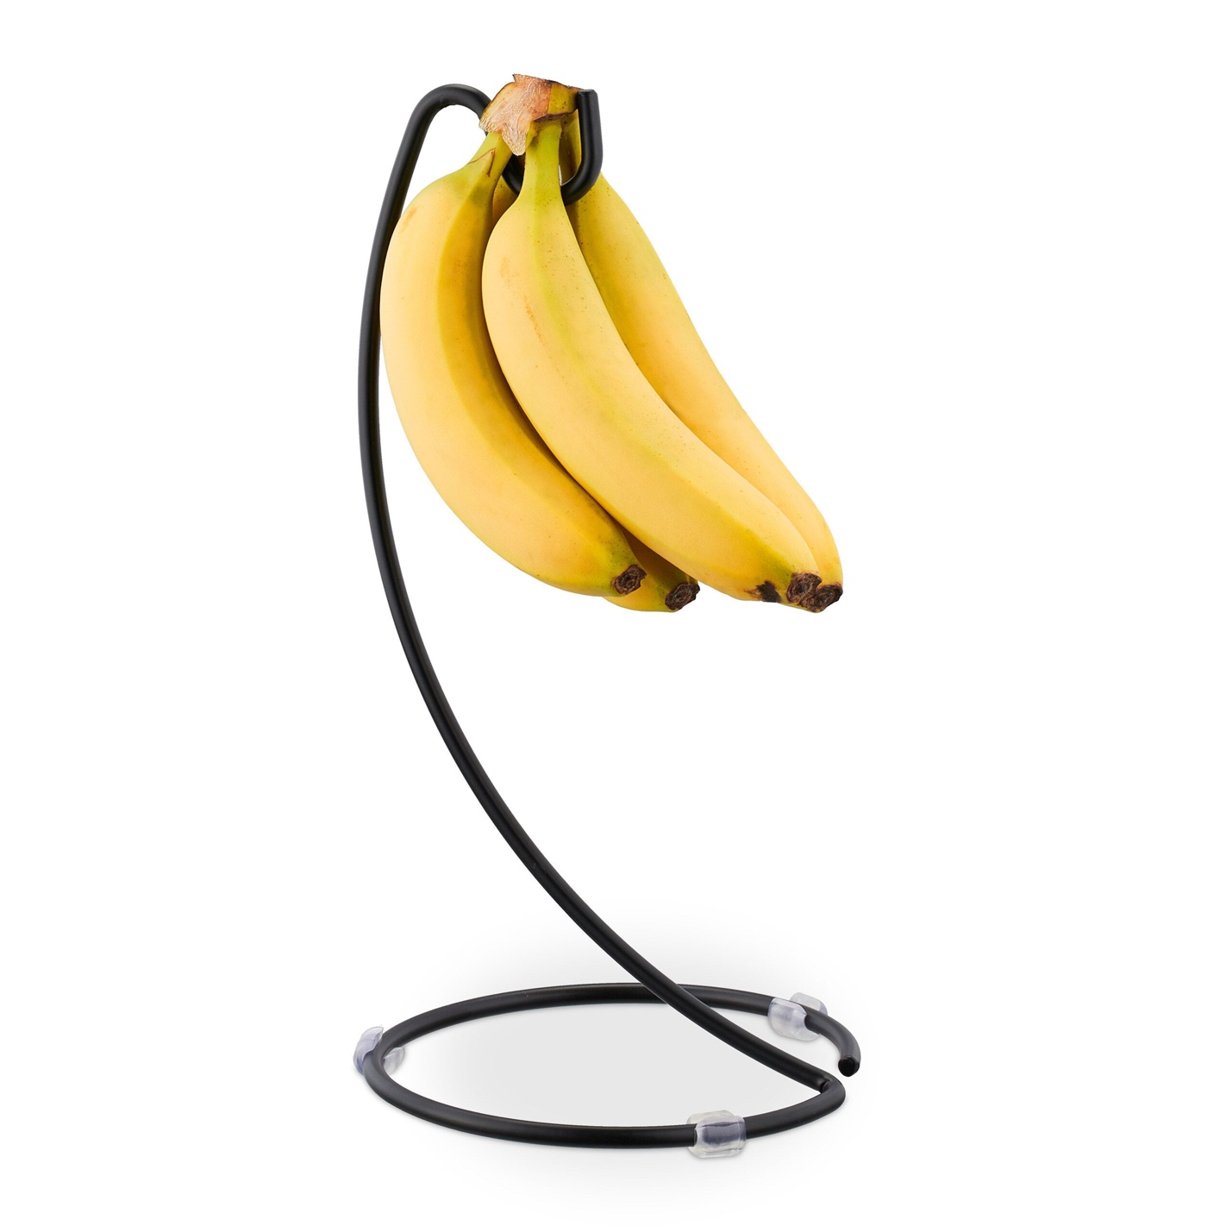
Relaxdays Black Banana Holder
$25.98
•
cz.relaxdays.com

Quick Highlights
- Everous Modern Banana Holder Tree Stand with Marble Base — Has a durable marble base and a stainless-steel/wood stem, built to support heavier banana bunches without tipping. Good balance of stability and modern look. Amazon+1
- Banana Holder With Marble Base, Metal Banana Hanger — A heavier base design where the stone/marble base adds real stability. Particularly useful if you often have large or heavy banana bunches. eBay+1
- Livabber Banana Holder with Marble Base — Another marble-base hanger that combines durability and a clean aesthetic; good if you want a mix of style and function. Amazon+1
- Winmien Double Hooks Banana Holder with Marble Base — Offers a stone base with double hooks (so you could hang more fruit), useful if you want extra capacity and solidity.
- Marble Banana Holder — A pure stone-base banana hanger (or at least stone-base design) built to keep bananas elevated and stable. Homeries
- WicksForge Hand Forged Metal Banana Stand — While not stone-base, this is a heavy forged-metal stand: often just as stable as stone-based ones. Good option if you want maximum durability and a slightly different aesthetic.
- Ebern Designs Stergis Banana Holder — A sturdy steel stand with a wide base that helps prevent tipping, even under heavier loads.
- Relaxdays Black Banana Holder — Simple, stable design with a weighted base and rubber feet for added grip — worth considering if you want stability and a darker finish to match black faucets/fixtures.

✅ My Assessment (Given Your Kitchen Style & Needs)
Since your kitchen has white counters/backsplash + black faucets and you care about strength, stability, and modern style, I’d lean toward marble-base models (Everous, Livabber, Winmien) or heavy-metal forged ones (like WicksForge). The marble-base stands in particular will give you a heavier footprint (so less tipping) while still keeping a minimalist, modern vibe.
If you want — I can check availability and ship-to-USA cost for 3–4 of these to see which is most practical to order right now. Want me to fetch that?


Sources

You said:
Any with a more rectalinear design?

ChatGPT said:
Good question. There are banana holders and fruit-stand designs with a more rectilinear or geometric base/structure — which tends to match modern kitchens better than the “tree-like” curved stands. Here are a few that lean toward straight-line, rectangular or geometric styling, or have bases/frames that read more angular or structured.

🍌 Banana Holders With More Rectilinear / Modern-Geometry Design

Rectangular Fruit Basket with Banana Hanger (Metal Wire, Wooden Base)
$19.99
•
Walmart - Seller

Livabber Banana Holder with Marble Base
$27.20
•
eBay - kamtau589

Wudkey Rectangular Fruit Basket with Banana Hanger and Wooden Base
$72.99
•
Home Depot

Zojila 'Andalusia' Fruit Holder and Serving Tray
$39.95
•
Zojila + others
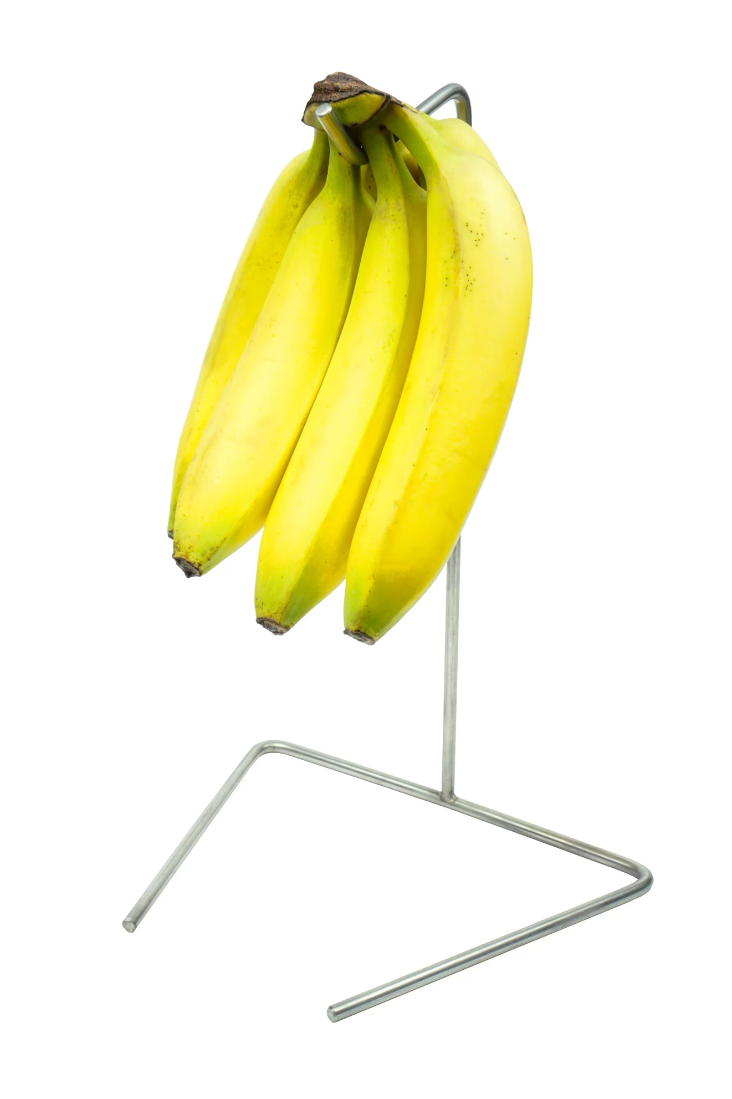
Modern Freestanding Stainless Steel Banana Holder
$60.51
•
Etsy

Pantry Works Banana Stand
$3.99
•
OrganizeIt.com

Yamazaki Home Tower Banana Stand
$19.55
•
west elm
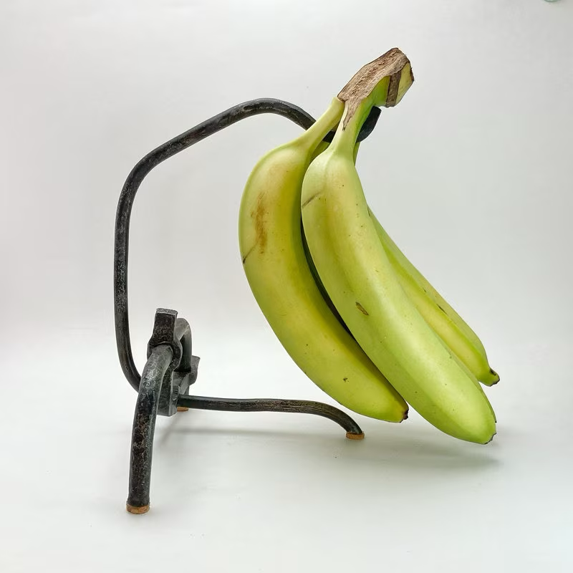
UrbanSmithy Industrial Steel Banana Holder
$79.00
•
Etsy

Quick take-aways
- Rectangular Fruit Basket with Banana Hanger (Metal Wire, Wooden Base) — This one uses a rectangular base and clean wire/frame layout, making it look more structured and geometric than a typical “banana tree.” Nice if you want something that blends with straight-lined cabinetry and counters while still hanging bananas.
- Livabber Banana Holder with Marble Base — More minimal and modern than many banana stands, with a stable base (often marble or weighted) and a simple, subtle hook. The base + hook styling isn’t ornate — more of a compact, contemporary silhouette. eBay+1
- Wudkey Rectangular Fruit Basket with Banana Hanger and Wooden Base — Combines a rectangular-style basket base with a hanging hook; good if you want fruit + bananas in one stable, structured package rather than a tree-like stand.
- Zojila 'Andalusia' Fruit Holder and Serving Tray — More of a multipurpose fruit holder + banana hanger with a rectangular frame/tray design. Great if you want clean lines and a more design-forward, architectural object instead of a “banana stand” look.
- Modern Freestanding Stainless Steel Banana Holder — Minimal lines, a freestanding stainless-steel design, and less “decorative flourish.” This is ideal for a sleek, modern kitchen environment.
- Pantry Works Banana Stand — A utilitarian but cleanly designed steel-base stand; its wider base helps with stability and the design is more compact and rectilinear, making it easy to integrate into a minimal kitchen.
- Yamazaki Home Tower Banana Stand — While still upright, this model feels more geometric and less “tree-like” than many banana stands; could work in a modern aesthetic if you prefer subtlety.
- UrbanSmithy Industrial Steel Banana Holder — This leans more industrial/minimalist: steel construction, angular geometry, and a design that’s more about function and form than “cute fruit stand.” Good if you want counter tools that match a modern or industrial kitchen.

✅ What “Rectilinear” Gives You (and Why It Matters)
Advantages of rectilinear / structured banana-holder design:
- Blends more cleanly with straight-lined counters, cabinets, backsplashes — minimal visual clutter.
- Often heavier or more stable base/footprint, reducing tipping risk (good if you get heavy banana bunches).
- Doubles as multipurpose fruit/produce organizer (fruit basket + banana hanger), saving counter space.
- Aesthetic matches modern, minimalist, or industrial kitchens (especially white counters + black fixtures).

If you like — I can pull up 5–10 of the most rectilinear + heavy-base banana holders globally available(not just US). Sometimes European or Japanese makers produce the cleanest geometry, and they can be interesting if you like more design-forward kitchen accessories. Do you want me to build that “global design-focused” list now?
Sources

You said:
how do I share a portion of a conversation?

ChatGPT said:
Here are the easiest ways to share just a portion of a ChatGPT conversation, depending on what you want to accomplish:

✅ Option 1 — Copy & paste the specific messages
The simplest and most reliable method:
- Highlight the exact messages you want to share
- Copy
- Paste into:
  - Email
  - Notes
  - Text message
  - Google Doc
  - Slack / Teams
This keeps only the part you want.
Most people use this method.

✅ Option 2 — Use ChatGPT’s built-in “Share” button (web)
This allows you to create a public link to a conversation but only from the web browser, not iPhone/iPad apps.
Steps:
- Open ChatGPT in a web browser (chat.openai.com)
- Open the conversation
- Click the “Share” icon (looks like an arrow coming out of a box) near the top
- Choose “Share a link”
- Copy the URL
- Anyone with the link can see that conversation
⚠️ You can’t select just a portion — it shares the full thread.

✅ Option 3 — Screenshot (good on iPad/iPhone/Mac)
Great for when the part you want is short.
- iPhone / iPad:
Press Side Button + Volume Up
- Mac:
Press ⌘ + Shift + 4 to select part of the screen
Then send the screenshot by text, email, etc.

✅ Option 4 — Export and edit (more advanced)
If you want to keep better records:
- Click your name (bottom left on web)
- Choose “Settings → Data Controls → Export data”
- You’ll receive a ZIP with all conversations
- You can copy just the part you want
Good for recordkeeping or long chats.

⭐ Best choice for most people
Just copy/paste the part of the conversation you want.
It’s private, fast, and lets you choose exactly which messages to include.

If you want, I can show you how to create a clean excerpt (formatted nicely) so it’s easy to share with Rahul, Jan, an advisor, etc.

ChatGPT can make mistakes. Check important info.

